Analysis of competitors and key players on the development of the Raiffeisen Online Mobile Application (ROMA)

## Objectives

## Research plan

1. **Short annotation**
2. **Analysis of banks**
   1. Rating of banks by categories
   2. Conclusions on direct and indirect competitors
3. **Analysis of the status of applications in the Google Play Market in the category "Finance" for key competitors**
   1. Competitors' products
   2. Number of downloads
   3. Number of reviews
   4. Ranking of applications based on users’ feedback
   5. Software version
   6. Summary table with visual analytics
   7. Conclusions on direct and indirect competitors
4. **Integration of banking services within the marketplace alike Rozetka.ua**
5. **Key advantages of competitors**
   1. Consumer loans
   2. Cards for online and internet purposes
6. **Headroom / Room for Improvement for ROMA application compared to competitors**

## Conclusion

# Research

**1. Short annotation**

This study aims to examine the current situation in the banking sector and analyze the position of RBA's competing banks on current market realities and consumer experience of using their [competitors'] relevant electronic mobile banking applications to determine the potential trajectory of relevant changes for ROMA. Due to limited resources, the main sources for conducting the study were the websites of [minfin.com.ua](https://minfin.com.ua/), the [National Bank of Ukraine](https://bank.gov.ua/), and [Google Play Market](https://play.google.com/).

**2. Analysis of banks**

**2.1. Rating of banks by categories**

Based on the data of the banks' reliability rating from the website of [minfin.com.ua](https://minfin.com.ua/) in early 2021, the RBA leads the Overall Rating, while occupying a high position in all the categories of the rating, being in the top-5 of the list. 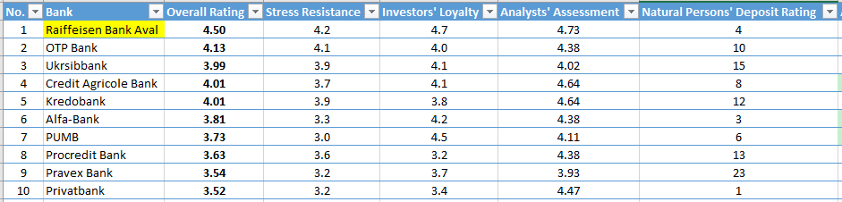

According to [thepage.ua](https://thepage.ua/ua/news/rejting-bankiv-2021-top-5-najpributkovishih-ta-najzbitkovishih), the top 5 most profitable banks in Ukraine in the same early 2021 is:

Top 5 most profitable banks of Ukraine in January - February 2021:

* Privatbank - UAH 1.3 billion in net profit;
* Raiffeisen Bank Aval - UAH 758.7 million;
* PUMB - UAH 676.1 million;
* Universal Bank - UAH 472 million;
* Alfa-Bank - almost UAH 427 million.

These banks are key competitors of the RBA.

It should be noted that Universal Bank (monobank) in the above rating ranks 13th overall, but it is in the top-10 for deposits of individuals.

**2.2. Conclusions on direct and indirect competitors**

Therefore, the following banks should be considered as the direct competitors resulting from the overall ranking of banks:

- Privatbank,

- OTP Bank,

- Ukrsibbank,

- Credit Agricole Bank,

- Alfa-Bank,

- PUMB,

- Kredobank,

- Universal Bank,

- Credit Bank.

Indirect competitors can be considered banks that are ranked in the top ten and below.

**3. Analysis of the status of applications in the Google Play Market in the category "Finance" for key competitors**

**3.1. Competitors' products**

Each of the competitors has its own mobile application in the Google Play Market. The general picture of the characteristics of the use of such an application will be considered in the context of the number of downloads, the number of reviews left by users of the application in the Google Play Market, the rating of the application based on user ratings, software version by the end of May 2021. The overview of the processed data will be given in the summary table.

**3.2. Number of downloads**

Thus, among the surveyed applications, according to the number of downloads, the RBA shares 3-8 positions with other banks, which have more than 1 million downloads. The first place is occupied by Privatbank with more than 10 million downloads, the second belongs to Universal Bank with more than 5 million downloads.

**3.3. Number of reviews**

According to the number of published user reviews, RBA ranks 8th with more than 20 thousand publications, while the first place belongs to Universal Bank with more than 500 thousand reviews. Second place goes to Privatbank with more than 300 thousand impressions from customers.

**3.4. Ranking of applications based on users’ feedback**

According to the average scoring of user rating, the RBA ranks 11th with 3.9 points out of 5 possible. The first place is occupied by Universal Bank with a score of 4.9, Abank24 is the second, having received 4.8 points.

**3.5. Software version**

Privatbank has a version of the sixth generation of software as for the main competitor bank - 6.30.00, but the new project of Universal Bank has a version of the first generation (1.36.5), RBA also uses the version of the first generation - 1.155.17.

**3.6. Summary table of visual analytics**

The table below is sorted by the rating of the mobile application in the Google Play Market.

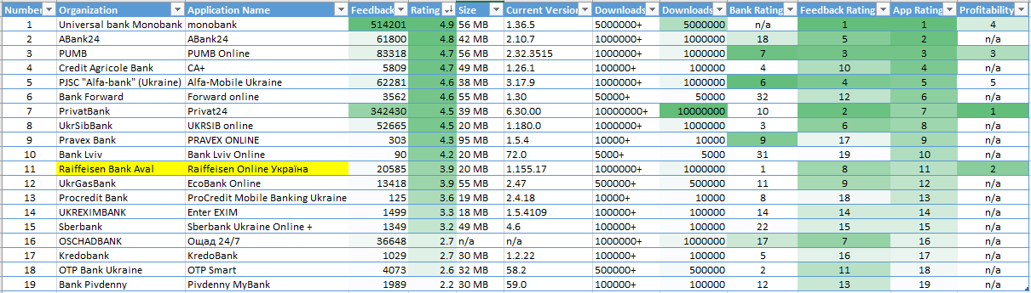

**3.7. Conclusions on direct and indirect competitors**

According to the results of the superficial assessment of mobile applications, the direct competitors are Universal Bank, PUMB, Privatbank, ABank24, UkrSibBank, and Alfa-Bank.

Universal Bank, Privatbank, and PUMB should be positioned as key competitors. The applications of these banks have numerous audiences and high ratings from users.

**4. Integration of banking services within the marketplace alike Rozetka.ua**

Services on consumer lending and deferred payments on the [Rozetka.ua](https://rozetka.com.ua/ua/) platform are actively provided by Privatbank, Universal Bank, Alfa-Bank, ABank24. RBA does not provide such services.

**5.1. Consumer loans**

Consumer loans from key competitors and the ability to process them quickly are integrated into most online stores and trading platforms. Speed and simplicity of registration make these services popular and in demand. The RBA does not provide such services directly when purchasing goods or services. This option is available on the RBA internet banking website for opening a loan and crediting funds to the client’s card - this leads to additional steps and time consumption.

**5.2. Cards for online and internet purposes**

The service of registering a card for online transactions is currently being actively implemented by major competitors and is available in their mobile applications of direct competitors. The RBA does not provide such opportunities yet.

**6. Headroom / Room for Improvement for ROMA application compared to competitors**

The positions of the RBA mobile application need the review and possible changes to be made in the strategy to improve the user experience and expand the effective functionality, as well as to encourage existing and potential customers to a constructive dialogue.

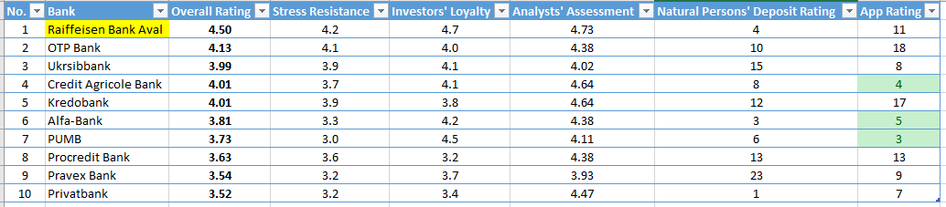

The table below shows the profitability of the bank (last column) against the rating of its application.

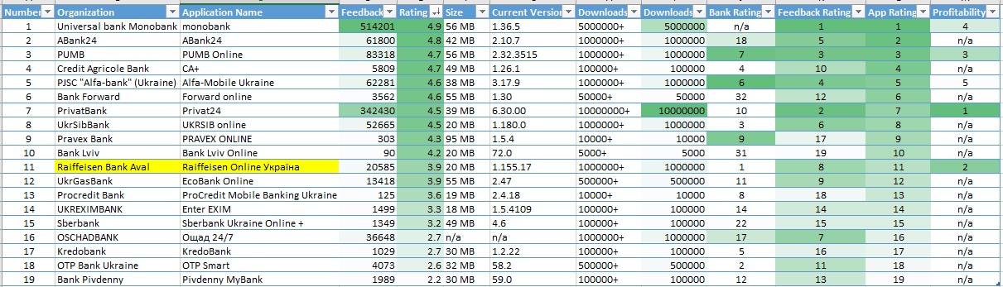

Achieving higher than the current user rating and increasing the downloads at least twice could be included in the metrics of the strategy to improve the qualitative and quantitative characteristics of ROMA for the next project period.

## Conclusions

Occupying the highest position in the overall rating of banks and being the second most profitable, RBA is being inferior to its direct competitors in terms of mobile applications. The lack of RBA credit products in online shopping resources also distances RBA from the positions of competitors with a wide range of services provided to online customers, and, above all, available through a mobile application.